Trak-TFRC Product Feature Brief

# Primary goals

To develop and create low power and wireless open source technology that aids in large-scale and long-term wildlife research, conservation, and monitoring the health of ecosystems.

Device list:

1. Lora Base Station
2. TamaCollar
3. SmallCollar
4. MediumCollar
5. Mouse Motel
6. Tamarin Group Monitor

*Names subject to change*

# Device Feature List

## LoRa Base Station (AKA LoraTester1)

A compact, portable device that can transmit and receive Lora messages, as well as store, display, and repeat them.

* Durable IP66 enclosure with tamper-proof controls and secure mount points
* LoRa 915Mhz/433Mhz with external SMA antenna mount
* OLED display
* SD card for data logging
* RTC for accurate time keeping
* GPS module
* Rechargeable battery for operating in portable mode or when deployed in the field with solar power
* Multiple modes of operation for receiving & logging LoRa messages, acting as a repeater, or transmitting data.
* Optional features currently under consideration-
  + USB connection to allow streaming of LoRa data in realtime to a PC
  + Operating in a mesh network to extend the range of LoRa Message reception.

**Product usage & lifecycle notes-**

The LT1 units are primarily intended to be either used in handheld mode, or deployed as receivers near feeding/monitoring sites to receive signals from collars. Ideally they should operate in a mesh to allow us to receive signals over a broader area in the dense amazonian jungle.

As these are stationary devices mounted either to towers or tall vantage points, maintenance is much easier to perform and we hope these devices can last upwards of 5 years.

The LT1 is a fairly flexible device, beyond changing it’s operating mode, users may wish to add additional sensors to monitor meteorological data or other.

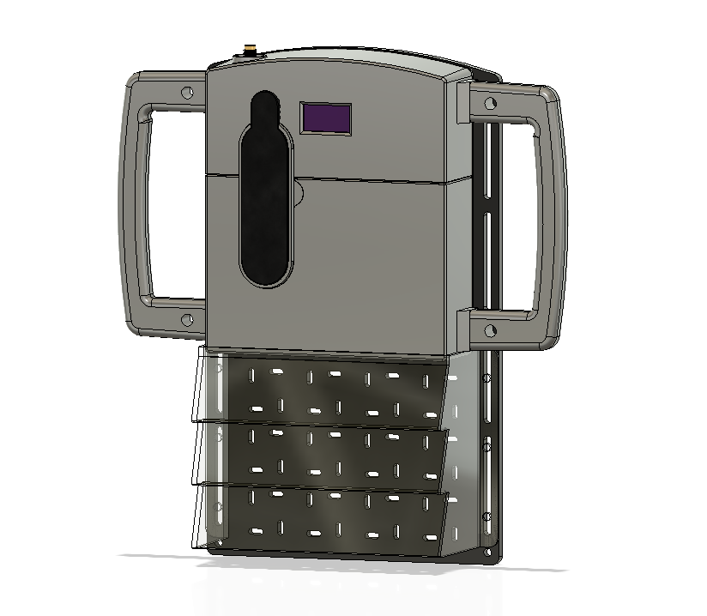

## TamaCollar

A lightweight tracker collar specifically designed to aid in tracking mature Tamarin species in the Peruvian Amazon.

* IP67 case/resin potting
* Size- <30*25*6mm
* Weight- <15g including ball chain collar
* LoRa 915Mhz/433Mhz
* RTC for accurate time keeping
* GPS module
* Primary non-rechargeable battery
* User configurable transmission schedule
* Optional features currently under consideration-
  + Data logging in case of successful device retrieval

**Product usage & lifecycle notes-**

The TC1 units are primarily designed to track wild Emperor Tamarins and Saddleback Tamarins, which are small new world monkeys weighing in at around 500g when grown.

These lightweight disposable collars are shipped with a magnet taped near the internal reedswitch, and will activate when the vet who’s attaching the devices removes the magnet.

In most cases, we will be programming the collars and shipping them sealed and ready-to-use, but configurable schedules are preferred. After a period of time, the crimp on the ball chain that holds the collar on will give way and fall off the animal. It is not expected to be recovered in most cases, but in the event that it is recovered, we can take apart the case and reuse the collars with minimal effort.

Changes to make-

* We are expecting to add a GPS antenna if required to help improve the GPS lock, both antennas would need to be as low-profile as possible.

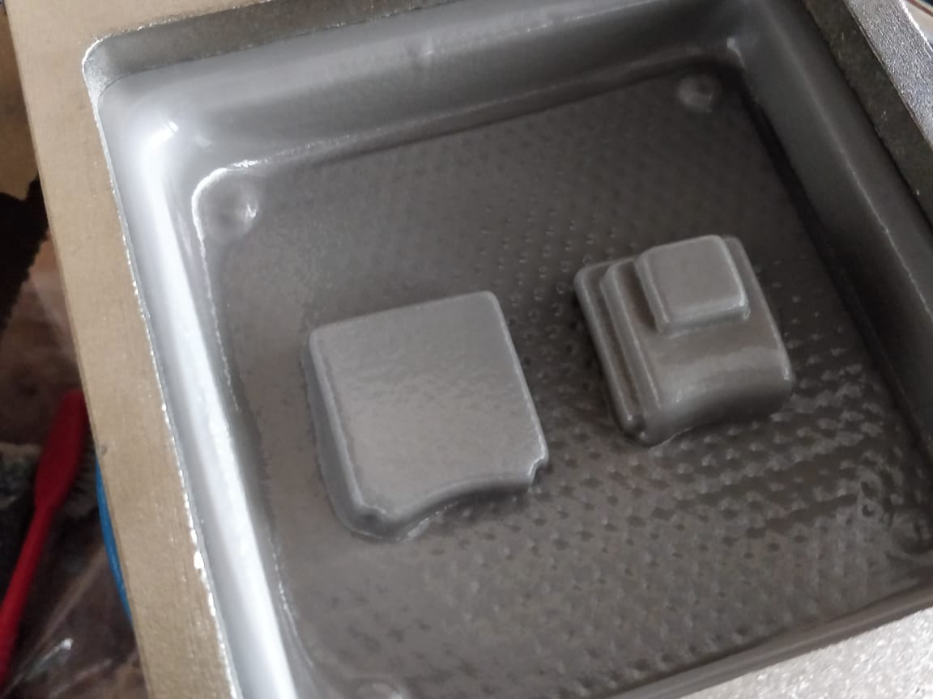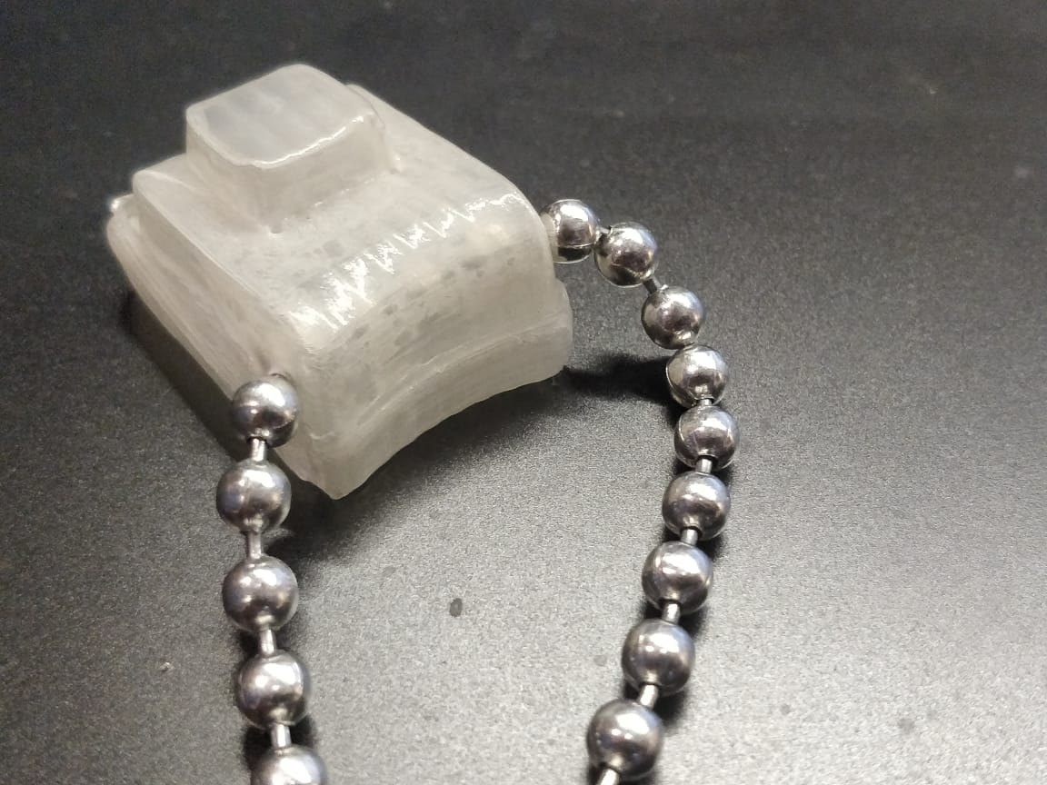

## SmallCollar

A minute tracker designed to aid in tracking smaller marsupials and rodents under 250g in the Peruvian Amazon.

At present, we are defining the brief for SC1 to allow us to monitor smaller animals than TC1, although no development has taken place yet. The goalposts are flexible so that we can push GPS monitoring to its absolute limits and bring the size and weight down as far as feasible.

* IP67 case/resin potting
* Size- TBD
* Weight- <TBD including ball chain collar
* LoRa 915Mhz/433Mhz
* RTC for accurate time keeping
* GPS module
* Primary non-rechargeable battery
* User configurable transmission schedule

# Timeline & Major Goals

* October End- Test and push TC1 and LT1 code to production
* November- Dispatch TC1 to Peru, TC1.1 as well if possible.
* March- Finalize and dispatch the following products to Peru
  + TamaCollar1.1
  + SmallCollar1
  + MediumCollar1.1
  + LoraTester1.1
  + TamaGroupMonitor/trap monitor
  + Mouse Motel

Note, I’ll make a high level gantt chart here